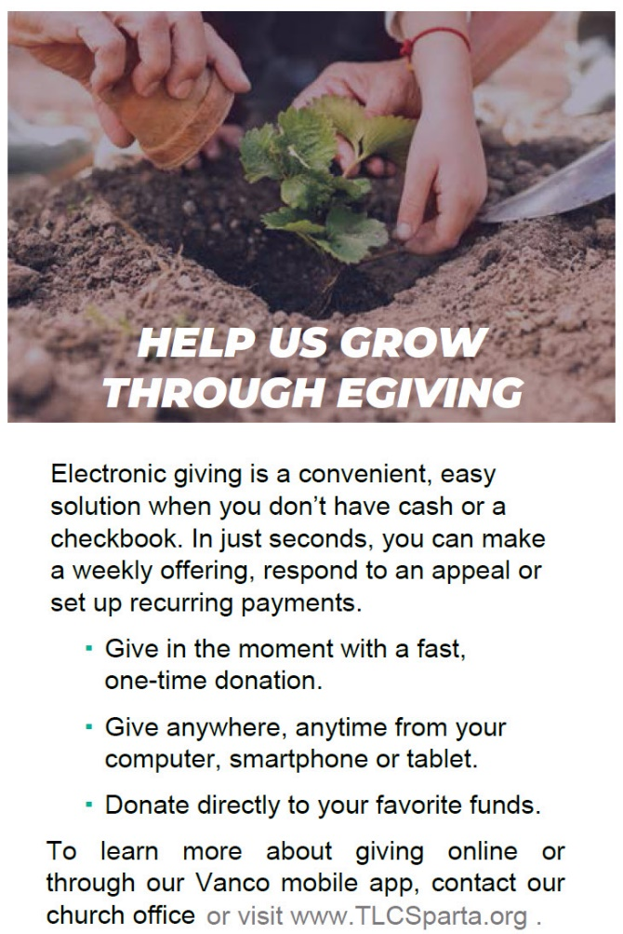
New Electronic Way to Give to God
Vanco Mobile replaces GivePlus – Vanco Mobile is the new free smartphone eGiving application from Vanco. For more information checkout: https://tlcsparta.wixsite.com/trinity/donatenow
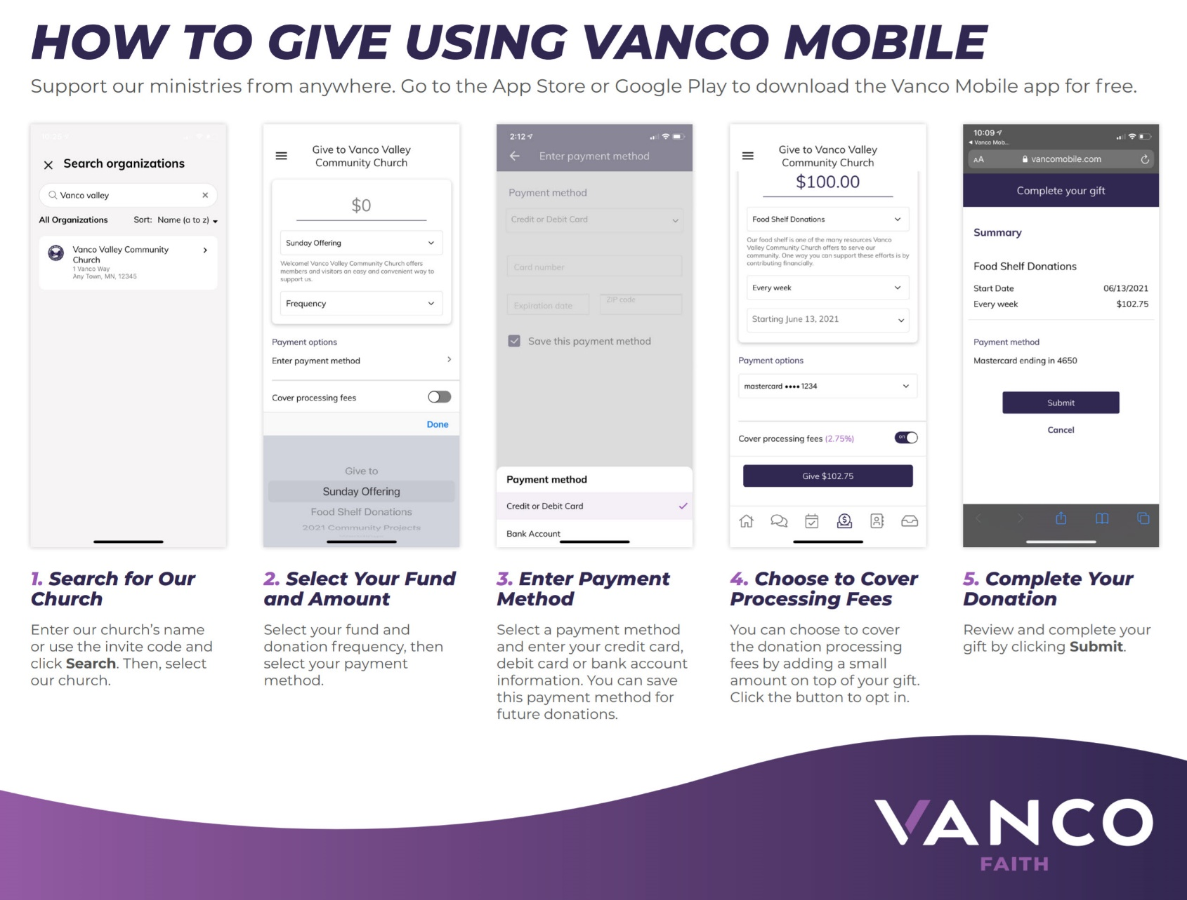
Everything we have is a gift from God. We are called to be wise stewards of those gifts. One simple way to carry out our call is to support the church’s mission through sacrificial giving. Our new eGiving options make it easy. eGiving allows you to set up automatic recurring contributions and view your complete online giving history at your convenience.
We Are An Offering
We lift our voices. We lift our hands. We lift our lives up to You. We are an offering.
Lord use our voices. Lord use our hands.
Lord use our lives they are Yours.
We are an offering.

