Holy Week
Devotions

Day 1

Read: 2 Corinthians 5:17

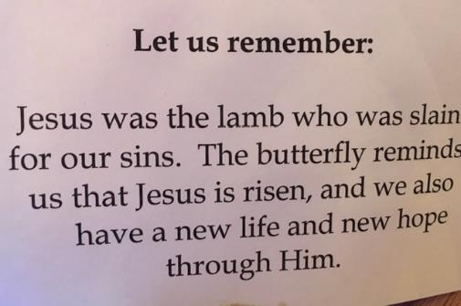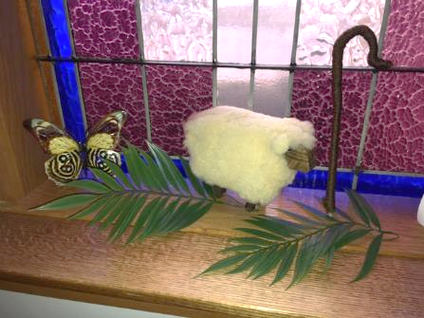

Prayer:
As we enter into Holy Week, help us ever remember we are new in you. These are difficult times. You went through difficult times. You know our suffering. We love you Lord and look forward to Easter and the resurrection. Amen

Day 2

Read: Mark 1: 9-11

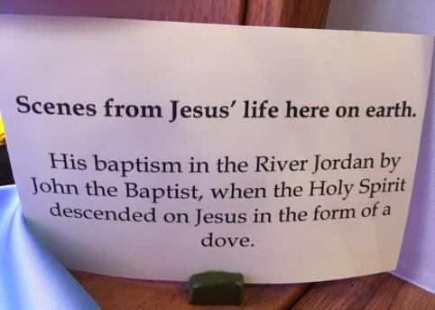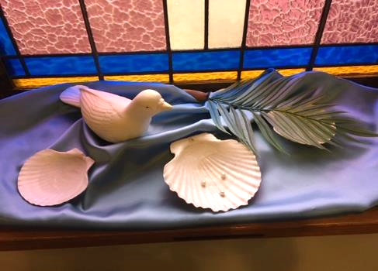

Prayer:
Lord, as the Spirit descended upon Jesus like a dove at His Baptism. Help us to remember that same Spirit is with us each and every day! In your name we pray. Amen

Day 3
Read: Mark 6: 30-44

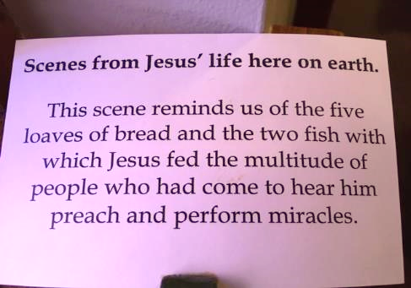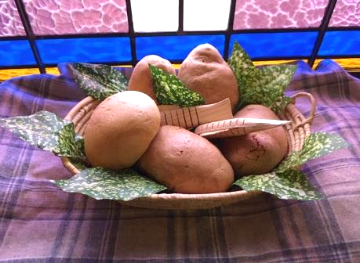

Prayer:
As Jesus and His disciples fed the 5,000 with 5 loaves and 2 fish, may we be ever mindful that you are our provider. All that we need, we find in you. Praise and thanks to you, oh Lord! Amen

Day 4
Read: John 12: 12-16

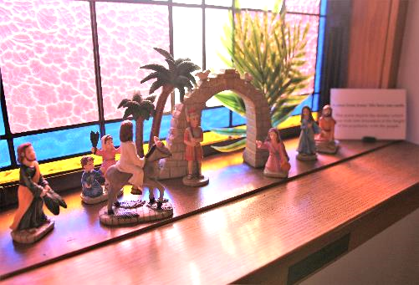

Prayer:
Praise and Glory to you oh Lord, you who willingly paraded into Jerusalem knowing what was to come. May our faith be ever so strong and our love as abundant. Thank you Lord Jesus. Amen

Day 5
Read: Luke 22: 7-20

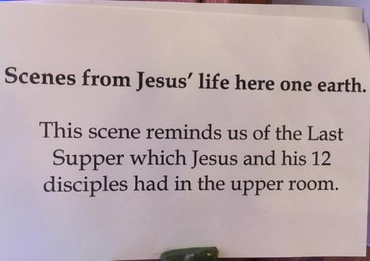

Prayer:
Lord God, we give you thanks for the Last Supper, for the actions you took to bring us forgiveness and everlasting life. We glorify you and wait in anticipation for the next time we can all join together to share in Holy Communion. In your name, Amen.

Day 6
Read: Mark 14: 66-72

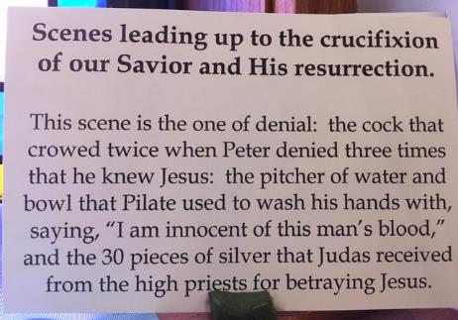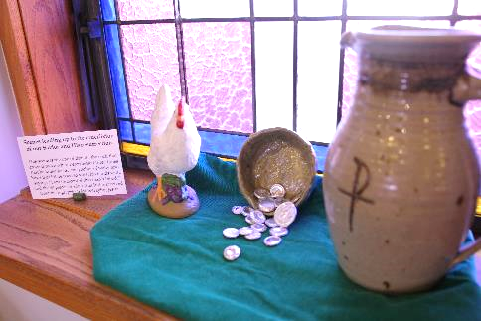

Prayer:
We all have been afraid at some point in our life. We have all denied you in one way or another. Lord give us the courage to bear all things. Give us the desire to be your humble servants. Give us the faith to persevere. We love you Lord! Amen

Day 7
Read: Mark 15: 16-20

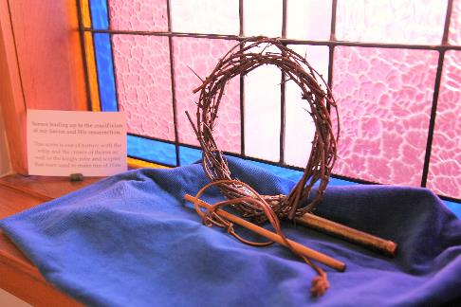

Prayer:
What a day Lord! What love you have shown us! What pain you have suffered! Our hearts cry out in your pain! Our sorrows are your sorrows. No other love is so great! In humble adoration. Amen.

Day 8
Read: Mark 15: 21-39

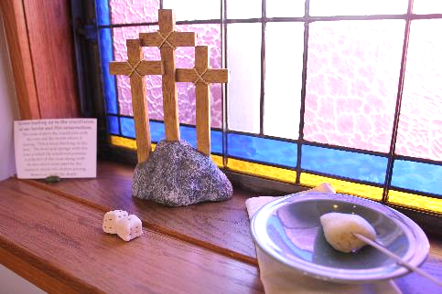

Prayer:
You knew Lord. You knew this was the path you had to take. You knew God, the father, had sent you to do this deed, to die this death. We are so grateful Lord, so humbled and so grateful! Amen.

Day 9
Read: Mark 16: 1-8

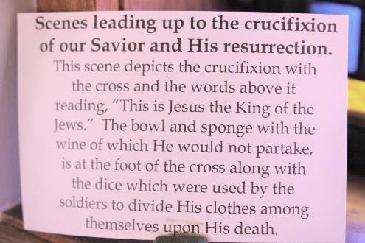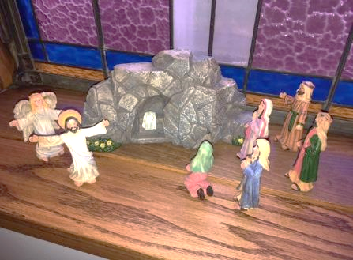

Prayer:
Alleluia! Praise God! Alleluia! You are risen! We understand the fear and disbelief of those who came to the tomb that morning. We are awed by the power of this work. We look forward to that great day when we will be raised with you! Alleluia! All glory and power to you! Amen

Day 10
Read: 1 John 1:7

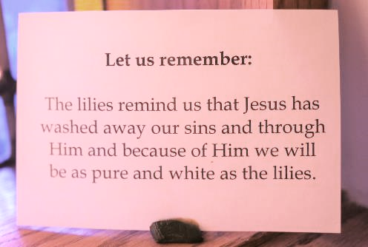

Prayer:
Oh Lord, through your death and resurrection you have made us clean. You have washed away our sins! Help us to be mindful of the sacrifice you made for us. All the days of our lives! Amen!

